**Accounting and Financial Analytics with zoho books**

**Assignment – 4**

**Task 1 – Stock Market Analysis**

**TITLE: ANALYSING THE PERFORMANCE OF TATA CONSULTANCY SERVIES (TCS)**

**Objective :** Analyzing the performance of TATA CONSULTANCY SERVIES (TCS) over the past few years.

**1.INTRODUCTION**

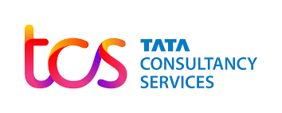

Tata Consultancy Services (TCS) is a multinational IT services, consulting, and solutions organization headquartered in Mumbai, India. It is part of the Tata Group, one of India's largest and most respected conglomerates. Established in 1968, TCS has grown to become one of the largest IT services firms globally, with operations spanning across six continents and serving clients in various industries.

Consistently recognized for its business performance, technological innovation, corporate governance, and social responsibility initiatives, TCS is a trusted partner for organizations worldwide seeking to harness the power of technology to drive growth, innovation, and transformation.

TCS offers a comprehensive range of services, including software development, system integration, consulting, cloud services, analytics, and business process outsourcing (BPO). It caters to diverse sectors such as banking and financial services, telecommunications, retail, manufacturing, healthcare, and more. TCS is renowned for its expertise in emerging technologies such as artificial intelligence (AI), machine learning, block chain, Internet of Things (IoT), and cyber security.

***Founding and History***:

TCS was founded in 1968 as a division of Tata Sons, the holding company of the Tata Group.

It was established by the legendary Indian industrialist J.R.D. Tata, along with F.C. Kohli, who is often referred to as the father of the Indian software industry.

Initially, TCS provided punched card services to sister company Tata Steel. Over time, it expanded into software services and IT consulting.

**Core Business:**

TCS primarily offers a wide range of IT services, including software development, system integration, consulting, cloud services, analytics, and business process outsourcing (BPO).

The company serves various industries, including banking and financial services, telecommunications, retail, manufacturing, healthcare, and more.

TCS has expertise in emerging technologies such as artificial intelligence (AI), machine learning, block chain, Internet of Things (IoT), and cyber security.

**Revenue and Market Position:**

TCS is consistently ranked among the top IT services companies globally in terms of revenue and market capitalization.

It is one of the largest employers in the IT industry, with a vast workforce comprising skilled professionals from diverse backgrounds.

**Global Presence:**

TCS has a significant global footprint, with operations spanning across six continents.

It operates in over 50 countries, serving clients in diverse regions and industries.

TCS has delivery centers and offices strategically located worldwide to provide seamless services to its clients.

**DATA ANALYSIS**

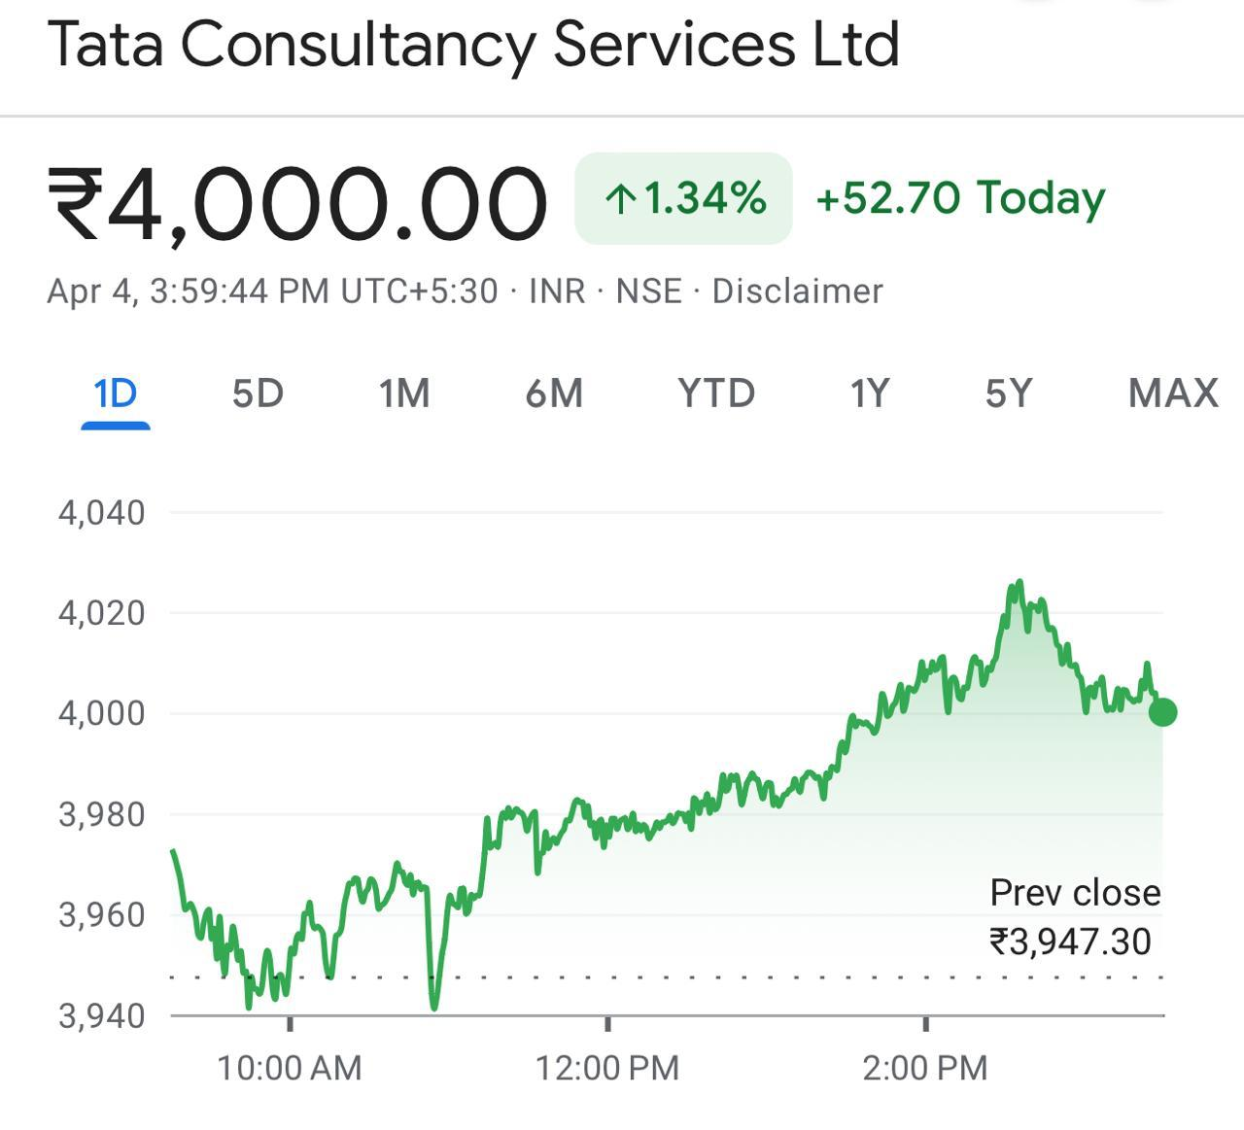

**2.HISTORICAL PRICE DATA CHART**

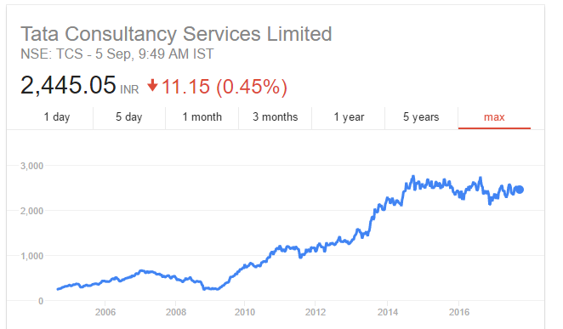

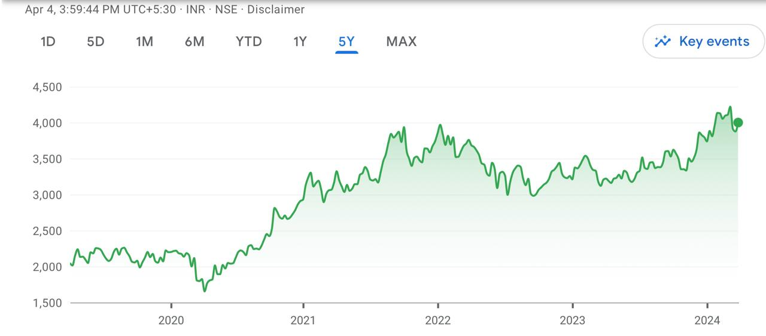

| Date | Price | Open | High | Low | Volume | Chg% |
| --- | --- | --- | --- | --- | --- | --- |
| Apr 2024 | 3,998.70 | 3,897.65 | 4,026.85 | 3,857.40 | 3.97M | 3.16% |
| Mar 2024 | 3,876.30 | 4,107.20 | 4,254.75 | 3,829.40 | 57.51M | -5.34% |
| Feb 2024 | 4,095.10 | 3,820.00 | 4,184.75 | 3,805.05 | 43.41M | 7.65% |
| Jan 2024 | 3,804.00 | 3,790.00 | 3,964.40 | 3,651.20 | 35.25M | 0.74% |
| Dec 2023 | 3,775.90 | 3,483.86 | 3,910.88 | 3,473.95 | 45.57M | 8.77% |
| Nov 2023 | 3,471.52 | 3,339.53 | 3,527.66 | 3,295.73 | 36.38M | 3.53% |
| Oct 2023 | 3,353.21 | 3,517.90 | 3,662.03 | 3,314.64 | 39.82M | -4.97% |
| Sep 2023 | 3,528.60 | 3,366.00 | 3,633.75 | 3,356.80 | 38.44M | 5.12% |
| Aug 2023 | 3,356.80 | 3,415.00 | 3,489.95 | 3,343.65 | 35.92M | -1.89% |
| Jul 2023 | 3,421.45 | 3,314.30 | 3,549.90 | 3,250.10 | 47.66M | 3.61% |
| Jun 2023 | 3,302.25 | 3,314.00 | 3,340.00 | 3,156.00 | 38.36M | 0.39% |
| May 2023 | 3,289.50 | 3,235.00 | 3,372.00 | 3,173.15 | 36.62M | 2.18% |
| Apr 2023 | 3,219.25 | 3,224.95 | 3,272.95 | 3,070.25 | 43.82M | 0.42% |
| Mar 2023 | 3,205.90 | 3,323.00 | 3,404.95 | 3,095.05 | 40.00M | -3.23% |
| Feb 2023 | 3,312.85 | 3,363.00 | 3,575.00 | 3,299.90 | 31.34M | -1.37% |
| Jan 2023 | 3,358.70 | 3,196.26 | 3,458.45 | 3,136.47 | 39.92M | 5.22% |
| Dec 2022 | 3,192.04 | 3,357.00 | 3,410.91 | 3,100.84 | 32.37M | -3.95% |
| Nov 2022 | 3,323.48 | 3,150.68 | 3,360.92 | 3,103.29 | 35.50M | 6.19% |
| Oct 2022 | 3,129.75 | 2,935.54 | 3,135.49 | 2,914.95 | 36.56M | 6.28% |
| Sep 2022 | 2,944.90 | 3,126.67 | 3,204.88 | 2,868.00 | 53.94M | -6.43% |
| Aug 2022 | 3,147.40 | 3,260.95 | 3,360.63 | 3,019.83 | 34.34M | -2.75% |
| Jul 2022 | 3,236.34 | 3,195.28 | 3,266.83 | 2,894.37 | 59.85M | 1.07% |
| Jun 2022 | 3,202.24 | 3,320.74 | 3,408.26 | 2,963.81 | 50.69M | -2.89% |
| May 2022 | 3,297.55 | 3,450.02 | 3,477.51 | 3,091.43 | 51.12M | -5.14% |

**Summary**

**Highest**

4,254.75

**Lowest**

2,868.00

**Difference**

1,386.75

**Average**

3,410.16

**Chg. %**

15.03

**3.KEY METRICS**

1. **Revenue**: TCS's total revenue is a fundamental indicator of its financial health and growth. It includes revenue from various services such as IT consulting, software development, and business process outsourcing.
2. **Profit Margin**: Profit margin measures the percentage of revenue that translates into profits after accounting for all expenses. It's an important metric for assessing TCS's operational efficiency and profitability.
3. **Net Income**: Net income represents the total profit or earnings generated by TCS after deducting all expenses, including taxes and interest. It reflects the company's bottom-line performance.
4. **Earnings Per Share (EPS)**: EPS indicates the portion of TCS's profit allocated to each outstanding share of its common stock. It's a widely tracked metric by investors to assess the company's profitability on a per-share basis.
5. **Bookings/Order Backlog**: This metric measure the value of contracts or projects TCS has secured but not yet completed. It provides insight into the company's future revenue potential and backlog of work.
6. **Client Metrics**: These include metrics like the number of active clients, client retention rate, and client satisfaction scores. They help gauge TCS's ability to attract and retain customers while delivering quality services.
7. **Employee Metrics**: Metrics such as employee headcount, attrition rate, and employee satisfaction scores are crucial for assessing TCS's workforce management and talent retention strategies.
8. **Revenue by Geography and Industry Verticals**: Analyzing revenue distribution by geographical regions and industry verticals provides insights into TCS's market diversification and exposure to different sectors.
9. **Digital Revenue Growth**: Given the increasing importance of digital services, tracking the growth of TCS's digital revenue is essential for understanding its ability to capitalize on digital transformation opportunities.
10. **Operating Cash Flow**: Operating cash flow measures the cash generated from TCS's core business operations. It's a key indicator of the company's ability to generate cash internally and fund its operations, investments, and dividends.

* **PERCENTAGE CHANGE IN STOCK PRICE**

**Percentage Change**= ***{(Current Price − Price One Year Ago) / (price one year ago)}×100***

For example, if the TCS stock price one year ago was $100 and the current price is $120, the percentage change would be:

Percentage Change=(120−100100)×100=20%

Percentage Change={(120−100​)/(100)}×100=20%

This calculation would give you the percentage change in TCS stock prices for the last year.

* **VOLATILITY**

Volatility in the context of stock prices refers to the degree of variation in trading price observed over time. It's typically measured using statistical metrics such as standard deviation or variance. Higher volatility indicates larger fluctuations in price, while lower volatility suggests more stable price movements.

To calculate the volatility of TCS stock, you would typically gather historical stock price data over a specific period and then compute the standard deviation or variance of the stock's returns over that period. The returns can be calculated as the percentage change in price from one trading day to the next.

Tata Consultancy Services is currently trading at Rs 3922.35, marking a 1.0% change today. Over the past 3 months, the average daily volatility stands at 2.65 units.

**TCS IV Percentile Rank**

TCS implied volatility (IV) is 52.8, which is in the **16%** percentile rank. This means that 16% of the time the IV was lower in the last year than the current level. The current IV (52.8) is -26.8% below its 20 day moving average (72.1) indicating implied volatility is **trending lower**.

**TCS IV vs 20-Day HV**

The current IV (52.8) in TCS is -31.4% below its 20 day HV (76.9) suggesting that options markets are predicting future volatility to trade below the most recent 20 day realized volatility.

**TCS IV vs 252-Day HV Divergence**

Traders frequently use the difference between implied volatility and historical volatility to measure divergence from the mean. Using the 252 HV as the long term benchmark, the implied volatility (52.8) is currently -28.3% below the 252 day HV (73.6) mean.

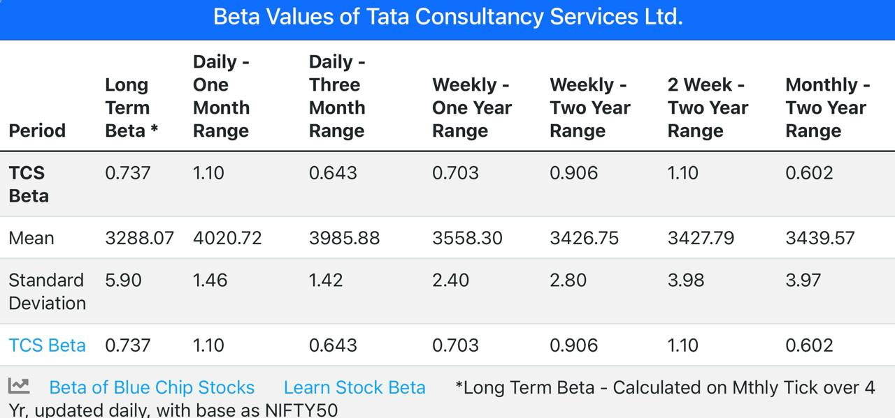

* **AVERAGE TRADING VOLUME**

On the previous trading day, Tata Consultancy Services closed at Rs 3947.30 with a trading volume of 3,973,090 shares, surpassing the average volume of the past 7 days which stood at 2,999,303 shares

DAILY PERCENTAGE AND VOLUME ANALYSIS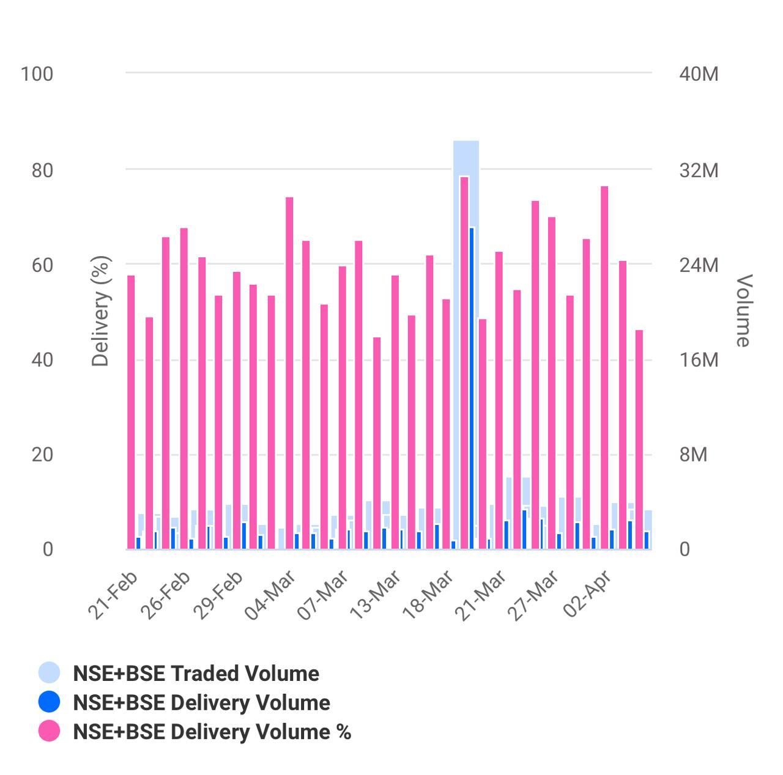

**4. STOCK COMPARISON WITH RELATED STOCK INDEX**



|  |  |  |  |  |  |  |  |  |  |
| --- | --- | --- | --- | --- | --- | --- | --- | --- | --- |
| Symbol | TCS | NFTY | |  | |  | |  | |
| Company | The Container Store Group Inc | FT India Nifty 50 EW ETF | |  | |  | |  | |
| **Price Information** |  | | | | | | | | |
| Exchange | NYSE | | NASDAQ | |  | |  | |  |
| Open | 1.1400 | | 57.30 | |  | |  | |  |
| High | 1.2000 | | 57.51 | |  | |  | |  |
| Low | 1.1400 | | 57.30 | |  | |  | |  |
| Last | 1.1900 | | 57.42 | |  | |  | |  |
| Change | +0.0900 | | +0.13 | |  | |  | |  |
| % Change | +8.18% | | +0.23% | |  | |  | |  |
| Volume | 104,937 | | 5,463 | |  | |  | |  |
| 20-Day Average Volume | 361,171 | | 25,218 | |  | |  | |  |
| Previous Close | 1.1000 | | 57.29 | |  | |  | |  |
| Industry | Consumer Prdts - Misc Discr | | N/A | |  | |  | |  |
| Has Options | Yes | | Yes | |  | |  | |  |
| **Technicals** |  | | | | | | | | |
| 20-Day Moving Average | 1.1155 | | 56.62 | |  | |  | |  |
| 20-Day Raw Stochastic | 66.47% | | 72.85% | |  | |  | |  |
| 20-Day Relative Strength | 46.48% | | 58.39% | |  | |  | |  |
| Weighted Alpha | -59.39 | | +34.15 | |  | |  | |  |
| Today's Opinion | 88% Sell | | 96% Buy | |  | |  | |  |
| Previous Opinion | 100% Sell | | 96% Buy | |  | |  | |  |
| Last Month's Opinion | 100% Sell | | 100% Buy | |  | |  | |  |
| **Performance** |  | | | | | | | | |
| **5-Days** |  | | | | | | | | |
| %Chg | +7.26% since 03/27/24 | | +2.75% since 03/27/24 | |  | |  | |  |
| Low | 1.0700 on 04/02/24 | | 56.73 on 03/28/24 | |  | |  | |  |
| High | 1.2000 on 04/04/24 | | 57.51 on 04/04/24 | |  | |  | |  |
| **1-Month** |  | | | | | | | | |
| %Chg | -11.29% since 03/04/24 | | -0.26% since 03/04/24 | |  | |  | |  |
| Low | 0.9815 on 03/18/24 | | 55.34 on 03/19/24 | |  | |  | |  |
| High | 1.3050 on 03/05/24 | | 58.25 on 03/08/24 | |  | |  | |  |
| **3-Month** |  | | | | | | | | |
| %Chg | -51.04% since 01/04/24 | | +5.62% since 01/04/24 | |  | |  | |  |
| Low | 0.9500 on 02/07/24 | | 53.37 on 01/23/24 | |  | |  | |  |
| High | 2.4600 on 01/05/24 | | 58.25 on 03/08/24 | |  | |  | |  |
| **6-Month** |  | | | | | | | | |
| %Chg | -45.88% since 10/04/23 | | +19.34% since 10/04/23 | |  | |  | |  |
| Low | 0.9500 on 02/07/24 | | 46.60 on 10/26/23 | |  | |  | |  |
| High | 2.5200 on 12/26/23 | | 58.25 on 03/08/24 | |  | |  | |  |
| **Key Statistics** |  | | | | | | | | |
| Market Capitalization, $K | 56,773 | | 191,922 | |  | |  | |  |
| Shares Outstanding, K | 51,612 | | 3,350 | |  | |  | |  |
| Annual Sales | 1,047,260,000 | | 0 | |  | |  | |  |
| Annual Net Income | -158,860,000 | | 0 | |  | |  | |  |
| Last Quarter Sales | 214,900,000 | | N/A | |  | |  | |  |
| Last Quarter Net Income | -6,430,000 | | N/A | |  | |  | |  |
| 60-Month Beta | 1.13 | | 0.72 | |  | |  | |  |
| **Per-Share Information** |  | | | | | | | | |
| Most Recent Earnings | -0.08 on 02/06/24 | | N/A | |  | |  | |  |
| Latest Earnings Date | 05/21/24 | | N/A | |  | |  | |  |
| Most Recent Dividend | N/A | | 0.079 on 03/21/24 | |  | |  | |  |
| Next Ex-Dividends Date | N/A | | 03/21/24 | |  | |  | |  |
| **Ratios** |  | | | | | | | | |
| Price/Earnings ttm | 0.00 | | 17.01 | |  | |  | |  |

**5.KEY EVENTS OF TCS**

Over the past few years, Tata Consultancy Services (TCS) has experienced several significant events and milestones. Here are some key events that have occurred:

**Leadership Changes**: TCS saw leadership changes with Rajesh Gopinathan taking over as CEO and managing director from Natarajan Chandrasekaran in February 2017. These transitions brought changes in strategic direction and focus areas.

**Expansion and Global Presence**: TCS continued to expand its global footprint, opening new offices and delivery centers in various countries to serve its clients better. Expansion efforts were particularly notable in regions such as North America, Europe, and Asia-Pacific.

**Digital Transformation Initiatives**: TCS intensified its focus on digital transformation, investing in new technologies such as artificial intelligence (AI), machine learning (ML), cloud computing, and Internet of Things (IoT). The company launched several digital solutions and services to help clients modernize their businesses.

**Acquisitions and Partnerships**: TCS made strategic acquisitions to strengthen its capabilities and offerings. For example, in 2017, TCS acquired W12 Studios, a digital design studio based in London, to enhance its digital design and customer experience capabilities. TCS also formed partnerships with technology companies, universities, and startups to foster innovation and collaborate on research and development projects.

**Employee Initiatives and Training Programs**: TCS continued to invest in its workforce through various employee initiatives and training programs. The company launched re skilling and up skilling programs to equip employees with in-demand digital skills and support their career growth.

**Recognition and Awards**: TCS received recognition and awards for its performance, innovation, and corporate social responsibility initiatives. For instance, TCS was ranked as the world's most valuable IT services brand by Brand Finance in 2020 and received accolades for its sustainability efforts and diversity and inclusion practices.

**COVID-19 Response**: Like many companies, TCS navigated the challenges posed by the COVID-19 pandemic. The company swiftly transitioned to remote work arrangements, implemented safety protocols, and supported clients in adapting to the new business environment. TCS also launched several initiatives to provide relief and support to communities affected by the pandemic.

These are just a few examples of key events that have occurred in TCS over the last few years. The company continues to evolve and adapt to changes in the industry and the broader business landscape.

*THANK YOU*

BY: M SUNNY APUROOP

BBA

Dr. L. BULLAYYA COLLEGE

ANDHRA UNIVERSITY